**We Are Healthy**

**Maths**

This term we will be developing our knowledge of place value, expanding into 3 digit numbers with hundreds, tens and ones. We will be learning about different ways of representing numbers physically with concrete and visual manipulatives.

We will also be looking at addition and subtraction. We will be develoiping our understanding of adding 10s and 100s, as well as adding and subtracting 2 and 3 digit numbers without exchanging.

Did you know that 28% of adults in the UK are classified as being obese?

This term we will be learning all about how to maintain a healthy lifestyle. We will be learning about making the right choices with our diets and understanding what is in our food. We will understand what might happen to us if we start to make the wrong choices with our diets and lifestyles.

Year 3 – Term 1



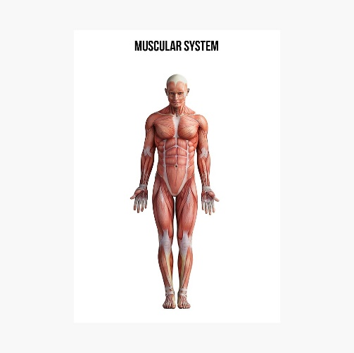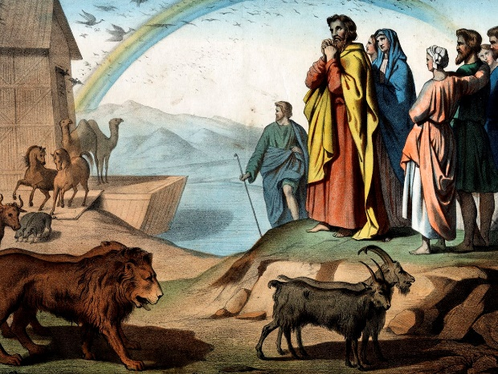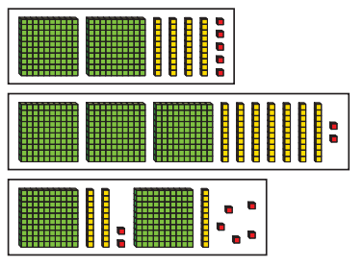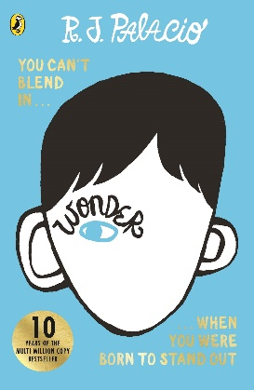

**RE**

Our RE topic this term will be focused around The People of God. We will look at the Story of Noah from the book of Genesis. We will discuss the question ‘What is it like to follow God?’, and understand the promises we make and follow with God.

**Science**

Our Science topic this term is ‘Animals including Humans’. We will be looking at how we can look after our bodies, as well as our muscles and skeleton.

**English**

We will be taking inspiration from the book ‘Wonder’ by RJ Palacio, in which a child is born with a genetic condition which makes him “different” to everyone else…

We will be writing character descriptions based on the main character from the book Wonder, Auggie. We will be incorporating our knowledge of nouns, adjectives, verbs and adverbs to describe Auggie.

Our non-fiction writing will be a discussion text focusing around Auggie. We will consider both sides of the argument as to whether we believe Auggie should go to school or not and present a unbiased text to weigh up the discussion.

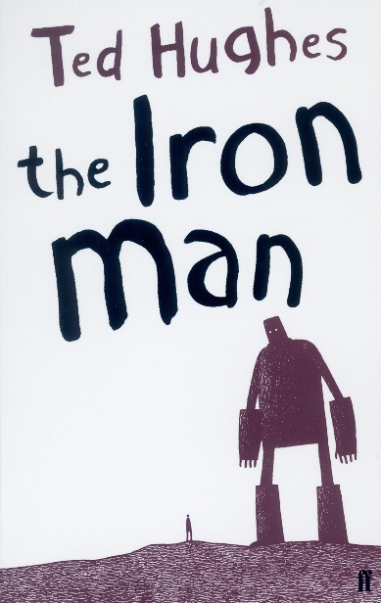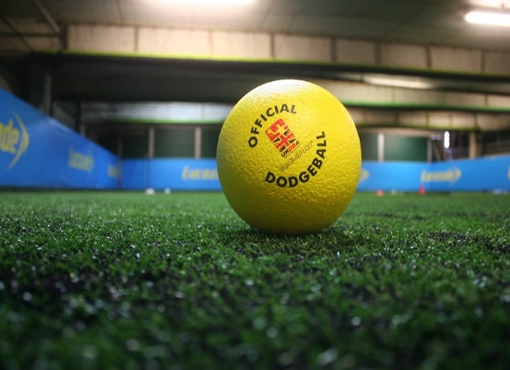

**PE**

PE will be on Thursdays with Mr Harris. Our unit for this term is dodgeball, where we will develop throwing, catching and reflex skills, as well as continuing our tactical awareness and understanding of different sports. PE lessons will be indoor in the hall.

In addition, we will have dance on Tuesdays with dance teacher Miss Needham.

Children will need to wear the appropriate PE kit to school on both of these days.

**Contact**

Please remember that if you have any questions or queries regarding to your child’s learning you can contact me via Class Dojo.

**Spanish**

We will be continuing to develop our Spanish skills using our scheme of learning, Primary Languages Network. This term, we will be learning how to meet and greet people and have basic conversations, before learning numbers from 0-20.

**Home learning**

**Reading** – Please read every day and fill in your reading record. This can be filled in by the pupil. Don’t forget, children can read to themselves as well as to an adult.

**Spelling** – Please look at the 100 Year 3 and 4 spellings. Try to focus on the structure of the sounds of each word.

**Maths** – Please remember to practice times tables regularly.

**Reading**

Our class reading book this term will be ‘The Iron Man’ by Ted Hughes.

We will be using reading VIPERS to help us to develop our Vocabulary, Inference Skills, Explanation and retrieval skills, as well as helping us to make predications and summaries.

Please remember that your child should be aiming to read every day after school where possible. This can be reading to themselves, to someone else or being read to. A combination of all three would be perfect!